|  |
| --- |
| **EXP: 2 JAVASCRIPT** |

**2) Write JavaScript to validate the following fields of the Registration page. a) First Name (Name should contains alphabets and the length Should not be less than 6 characters).**

1. **Password (Password should not be less than 6 characters length).**
2. **E-mail id (should not contain any invalid and must follow the standard pattern name@domain.com)**
3. **Mobile Number (Phone number should contain 10 digits only).**
4. **Last Name and Address (should not be Empty).**

**AIM:**

Write JavaScript to validate the following fields of the Registration page.

**ALGORITHM:**

**Step 1: Create the HTML Form**

* + Add input fields for First Name, Last Name, Email, Password, Mobile Number, and Address.
  + Add a Submit Button to trigger validation.

**Step 2: Apply Elegant CSS Styling**

* + Add responsive styling with hover effects.
  + Improve form layout, input fields, and button styles.

**Step 3: Add JavaScript for Validation**

* + Validate each field and show error messages if invalid.
  + Display "Registration Successful!" if all inputs are valid.

**Step 4: Full Working Code in One HTML File**

* + Copy and paste the code below into an .html file and open it in a browser.

**PROGRAM:**

<!DOCTYPE html>

<html lang="en">

<head>

<meta charset="UTF-8">

<meta name="viewport" content="width=device-width, initial-scale=1.0">

<title>Registration Form Validation</title>

<style>

body {

font-family: Arial, sans-serif;

background: linear-gradient(120deg, #a1c4fd, #c2e9fb);

display: flex;

justify-content: center;

align-items: center;

height: 100vh;

margin: 0;

}

.form-container {

background: #fff;

padding: 30px;

border-radius: 10px;

box-shadow: 0 8px 16px rgba(0, 0, 0, 0.2);

width: 100%;

max-width: 400px;

}

.form-container h2 {

text-align: center;

margin-bottom: 20px;

}

.form-group {

margin-bottom: 15px;

}

.form-group label {

display: block;

margin-bottom: 5px;

}

.form-group input {

width: 100%;

padding: 10px;

border: 1px solid #ccc;

border-radius: 5px;

}

.form-group input:focus {

border-color: #4a90e2;

outline: none;

}

.form-group button {

width: 100%;

padding: 10px;

background-color: #4a90e2;

color: white;

border: none;

border-radius: 5px;

cursor: pointer;

}

.form-group button:hover {

background-color: #357ab7;

}

</style>

</head>

<body>

<div class="form-container">

<h2>Registration Form</h2>

<form onsubmit="return validateForm()">

<div class="form-group">

<label for="firstName">First Name:</label>

<input type="text" id="firstName" name="firstName">

</div>

<div class="form-group">

<label for="password">Password:</label>

<input type="password" id="password" name="password">

</div>

<div class="form-group">

<label for="email">E-mail:</label>

<input type="text" id="email" name="email">

</div>

<div class="form-group">

<button type="submit">Register</button>

</div>

</form>

</div>

<script>

function validateForm() {

const firstName = document.getElementById('firstName').value.trim();

const password = document.getElementById('password').value;

const email = document.getElementById('email').value.trim();

const nameRegex = /^[A-Za-z]{6,}$/;

const emailRegex = /^[\w.-]+@[\w.-]+\.\w{2,}$/;

if (!nameRegex.test(firstName)) {

alert('First Name should contain only letters and be at least 6 characters long.');

return false;

}

if (password.length < 6) {

alert('Password should be at least 6 characters long.');

return false;

}

if (!emailRegex.test(email)) {

alert('Please enter a valid email address.');

return false;

}

return true;

}

</script>

</body>

</html>

**OUTPUT:**

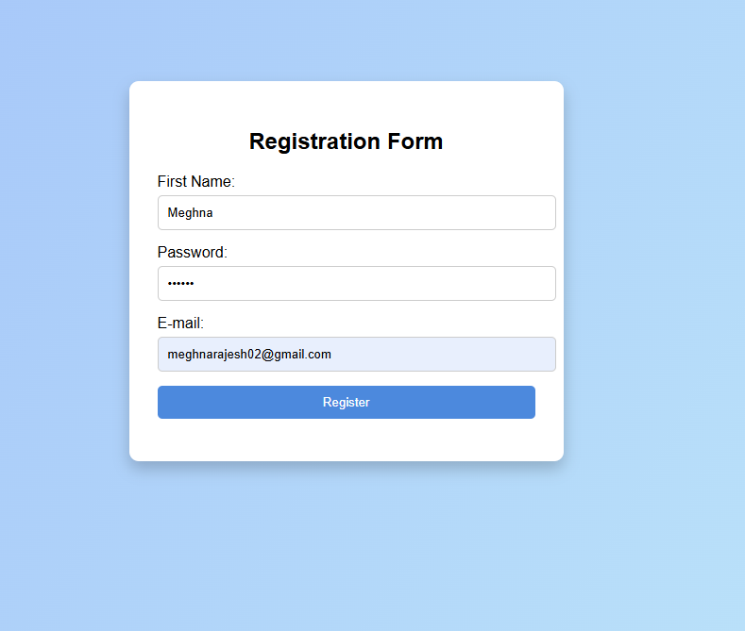

**RESULT:** TheRegistration Formwas successfully created usingHTML, CSS, and JavaScript.